**Brooklyn torah gazette**

**For parshas tetzaveh 5783**

Volume 7, Issue 25 (Whole Number 332) 11 Adar 5783/ March 4, 2023

**Printed L’illuy nishmas Nechama bas R’ Noach, a”h**

For a free subscription, please forward your request to [***keren18@juno.com***](mailto:keren18@juno.com)

**Behind the Bima Interview**

**With Mort Klein,**

**President of the ZOA**

**By Daniel Keren**

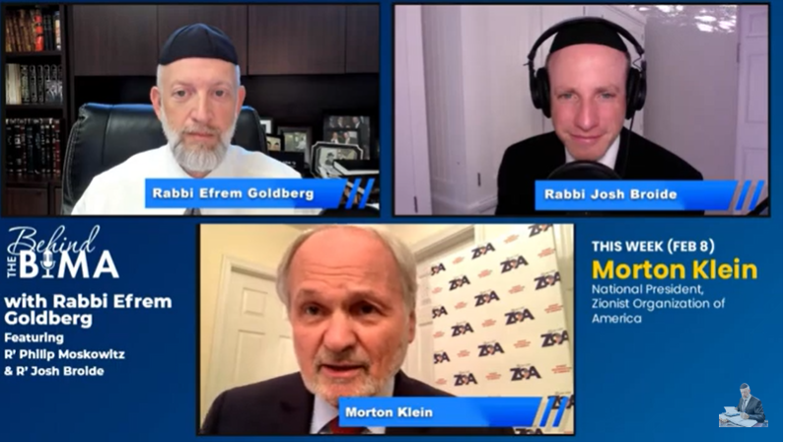

Rabbi Efrem Goldberg, is the Senior Rabbi of the Boca Raton Synagogue (BRS), a rapidly-growing congregation of over 800 families and over 1,000 children in Boca Raton, Florida. BRS is the largest Orthodox Synagogue in the Southeast United States. Rabbi Goldberg’s warm and welcoming personality has helped attract people of diverse backgrounds and ages to feel part of the BRS community, reinforcing the BRS credo of ‘Valuing Diversity and Celebrating Unity.’

Around the time that the Covid pandemic shut down much of America a couple of years ago including many synagogues when people were afraid to have close contact with others, Rabbi Goldberg and two of his associates – Rabbi Phillip Moskowitz and Rabbi Josh Broide started a podcast – “Behind the Bim” which has become popular with Jews not just in Boca Raton, but indeed round the English-speaking world.

Each week on Wednesday night, Rabbi Goldberg and his associates interview a featured individual on “Behind the Bima,” on a topic of Jewish interest. The featured guest on the February 8th “Behind the Bima” podcast – Episode #116 was Mort Klein, the National President of the Zionist Organization of America (ZOA).

**Overcoming Tourette’s Syndrome**

While I had known that Mort Klein was the longtime National President of the ZOA, there were many fascinating and inspiring aspects of this askan’s 30-year mission on behalf of Klal Yisroel. In the interview with Rabbi Goldberg and Rabbi Broide discussed with Mort Klein the fact that since the age of 8 has suffered from Tourette’s syndrome, a condition of the nervous system that causes people to have facial tics and have difficulty speaking. Mort Klein said that many women were turned off by his medical condition. But fortunately for the Jewish nation he married a woman named Rita who encouraged Mort Klein to become involved in defending Israel.

Mort Klein was born in a German Displaced Person’s camp in 1947. His father was a Satmar rabbi who immigrated to the United States and wound-up living in Philadelphia. What was amazing was that unlike the Satmar rebbe who was opposed to the existence of a secular lead State of Israel, Mort Klein’s father favored the Jewish homeland and communicated this attitude to his son. Had Mort Klein and his father settled in Williamsburg instead of Philadelphia, it is most likely that Mort would be a typical Satmar chasid and his name with be Mordechai or Mordie and not one of the greatest supporters of the State of Israel.

**Is Donald Trump a Friend of Anti-Semites**

An interesting topic that the rabbis behind the Bima brought up was that Mort Klein and the ZOA recently honored former President Donald Trump with the Theodor Herzl Gold Medallion in recognition of his being the best friend Israel’s ever had in the White House and President Trump also hosted at his Mar-a-Lago home two outrageous anti-Semites.

Mort Klein said that he publicly criticized President Trump for meeting with those well-known Jew haters, but that doesn’t negate the fact that he moved the United States embassy to Jerusalem and helped Israel by making possible the breakthrough Abraham Accords.

To watch this 1 hour and 7-minute podcast you can google #116 Behind the Bima – Special Guest – Mort Klein, President of the ZOA or <https://www.youtube.com/live/JyZ3xXmENYk?feature=share> The actual interview with Mort Klein begins at 13.27 minutes into the podcast.

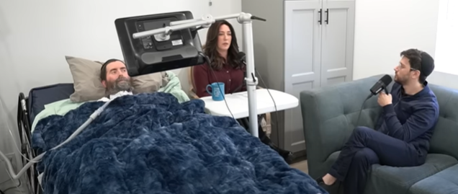

Another podcast just released a few days ago by host Yaakov Langer of Living L’Chaim was an interesting interview with Rabbi Yitzi & Dina Hurwitz. Yitzi a Chabad shaliach (emissary) in Southern California has for the past 13 years been suffering from ALS (Lou Gehrig’s Disease) and is only able to communicate today by eye communication with a computer.

Dina explained how she and her family have tried to handle the many challenges to their lives caused by her husband’s debilitating illness. One interesting take from the podcast was the remark of Mrs. Hurwitz that despite their difficult life, all of her seven children are still happy in their outlook towards what life has thrown them.

To view this podcast – google Our 10 Year Journey with ALS & How it Changed Our Lives – Rabbi Yitzi & Dina Hurwitz.

*Reprinted from the February 10, 2023 edition of The Jewish Connection.*

******************************************************************

And his sound shall be heard when he goes into the holy place (Ex. 28:35)

*In general, the Torah always emphasizes the importance of being humble and modest. If this is true for every Jew, how much more so does it apply to our Sages, who must set a good example by their behavior. Nonetheless, when it comes to preserving the sanctity of the Jewish people, our Rabbis must not be shy and are in fact obligated to speak out in a loud voice. (Chatam Sofer)*

*Reprinted from the Parshat Tetzaveh 5782/2022 edition of L’Chaim (Issue #1710)*

**Rav Avigdor Miller on**

**Lost Love, Lasting Loyalty**

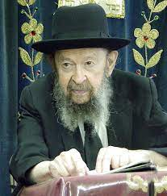

**QUESTION:** **How should one react if they find that they don’t love their partner anymore like they did in the beginning?**

**ANSWER:** And the answer is that love is not the criterion of behavior in marriage.  Love should be a result, but the criterion is loyalty.

We say in Yiddish, azoi vi men bet zich ois, azoi shluft men.  It means “the way you make your bed, that’s the way you should sleep.”  Look before you leap.  Once you leap, hold onto it.  That’s it forever.  Because if you’re going to regret and maybe there’s somebody better yet, then you’ll never remain married.  Every day you’ll change.

So, the attitude of Torah – not only Torah; lehavdil decent gentiles once upon a time in their wedding ceremony used to say, “Do you take this person for better or for worse?” and they said, “I do.”  And we, lehavdil, surelydo that!

Like I said, ודבק – loyalty has to be the criteria.  And forget about love.  Of course, it’s a duty; ואהבת לרעך כמוך – you have to love every fellow Jew.  And those people with whom you are frequently in contact, certainly!  And there are very many reasons why a woman and a husband should love each other more than strangers do. Of course, you can never forget the fundamental duty to love a fellow Jew.  You must love a fellow Jew!  We just don’t have time to think about everybody, to bestow love on every Jew.  We don’t have big enough hearts for that.  You need to be Avrohom Avinu or a big chossid. But for one’s own spouse, it’s not that difficult.  So, from time to time, it’s possible to generate some love.

But no matter what, even if romance long ago flew out of the window – and it does fly out immediately; of course, because it’s a false concept – nevertheless loyalty takes its place through thick and thin.

Here I see in the street a fat husband waddling down the street and a fat wife next to him.  They’re middle aged.  Nothing romantic.  But they’re loyal to each other.  They’re married and they’re going to stick together.  They’ll be buried side by side.  Nothing lovable anymore.  I look at them – I couldn’t imagine any romance between them.  It’s long past that age. And still they’re intensely loyal to each other.  If he would have a nervous breakdown, she would nurse him.  She wouldn’t send him away to the insane asylum.  If she’d be old and decrepit, he’d push her in a wheelchair.

Don’t you see an old man pushing an old woman in a wheelchair loyally?  He doesn’t say, “I’m going to get rid of her.  She’s too much of a bother.”

Here’s an old husband; he’s in diapers.  He’s senile.  But his wife is loyal to him till the end.  She changes his diapers every day five or six times. Because she married him and she’s going to remain with him til the last minute and she’s going to the next world and be side by side with him in Olam Haboh.

And that’s the ideal of a marriage.  It’s not built on romance.  It’s not built on any ideas of a Prince Charming or a princess.  It’s built on the idea of ודבק, loyalty. You’re together forever. It’s like part of your body.  You’re not going to say goodbye to part of your body because it’s not as good as it used to be.  You may have an old hand or even an old heart.  You’ll hold onto it as long as you can.

*Reprinted from the February 16, 2022 email of Toras Avigdor. Adapted from Tape #574 – November 1995*

*\*\*\*\*\*\*\*\*\*\*\*\*\*\*\*\*\*\*\*\*\*\*\*\*\*\*\*\*\*\*\*\*\*\*\*\*\*\*\*\*\*\*\*\*\*\*\*\*\*\*\*\*\*\*\*\*\*\*\*\*\*\*\*\*\*\**

*Moses and Aaron were of entirely different natures. Moses was given to seclusion and contemplation, as it states, “And Moses took his tent and went outside the camp,” whereas Aaron was a social being, involved with his fellow man and pursuing peace. G-d’s directive to Moses implied that he should emulate his brother’s ways, for a true Jewish leader cannot remain apart from his people. (Rabbi Meir of Premishlan)*

*Reprinted from the Parshat Tetzaveh 5782/2022 edition of L’Chaim (Issue #1710)*

**The Connection of the Menorah Oil and How a Jew Can**

**Utilize Suffering in this World**

**From the Teachings of the Lubavitcher Rebbe**

**Rabbi Menachem Mendel Schneerson, Zt”l**

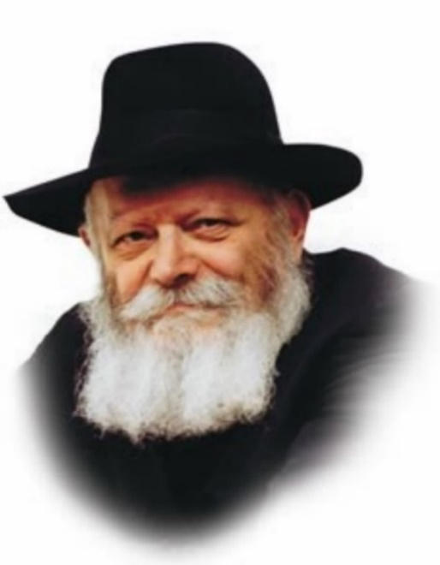

In this week’s Torah portion, Tetzaveh, we read of G-d’s command to Moses regarding the olive oil for the menora, as well as the priestly garments and the additional garments of the High Priest. The portion concludes with the instructions of the seven-day initiation into the priesthood of Aaron and his four sons.

The Torah portion begins with G-d telling Moses about the special olive oil: “And you shall command the children of Israel, and they shall take to you pure olive oil, crushed for lighting, to kindle the lamps continually.”

To get the purest olive oil, the olive was crushed in a mortar, and the first drop expressed was used for the oil to light the menora. Only the oil extracted this way could be used to light the menorah. The remainder of the olive was ground to extract more oil, but this oil was not for the menora.

What can we learn from this?

The kindling of the menora symbolized lighting up the souls of the Jewish people. For this, only the purest olive oil, extracted through crushing, was used.

The purest comes out through being crushed. It is the crushed, that ignite Jewish souls.

We all are “crushed,” we are tested with suffering in one form or another. What we do with it is our choice. You can choose to wallow in self-pity, or you can use your “crushing” experience, to lift up those around you.

Choosing to use your experience for the positive, will not only uplift those around you, but it will give meaning and purpose to your situation.

Before ALS, I was talented. I could teach, lecture, sing, dance, play guitar, and I was strong. Within two years, I watched that all slip away. Now I’m left with my heart, my brain and my smile. Being crushed has brought stronger connections, new abilities, higher purpose, and deeper meaning. Before, I used my talents to make people happy, and to educate them. Now I get to do that, and much more.

With this attitude, I have gained an added extra. I feel happy and fulfilled, and the people around me seem happy and uplifted. Yet, it is time for the crushing to end, and enjoying the light to begin. May it happen now with Moshiach!

Adapted by Rabbi Yitzi Hurwitz from the teachings of the Rebbe, yitzihurwitz.blogspot.com. Rabbi Hurwitz, who is battling ALS, and his wife Dina, are emissaries of the Rebbe in Temecula, CA.

*Reprinted from the Parshat Tetzaveh 5782/2022 edition of L’Chaim (Issue #1710) Adapted from the teachings of the Lubavitcher Rebbe, zt”l.*

***More Thoughts on Our Parsha***

*That they bring to you pure olive oil (Ex. 27:20)*

*“Pure olive oil” is an allusion to the Torah, implying that the Torah in its entirety was given to Moses at Mount Sinai: The Hebrew word for “pure,” “zach,” has the numerical equivalent of 27 – the 22 letters of the Hebrew alphabet, plus the five letters that have a different form when they come at the end of a word. (Ohr Torah)*

*You shall bring near to you Aaron your brother (Ex. 28:1)*

*You shall command – ve’ata tetzave (Ex. 27:30)*

*Chasidic thought interprets this verse to mean, “You shall connect yourself to...” Moses was commanded to establish a connection between his essence and the Jewish people. In an extended sense, this command can be understood as having been directed to every Jew, for each Jew has a spark of Moses in him. “You” refers to the essence of the soul, the fundamental core of every Jew’s being. This is revealed by the establishment of a bond with G-d’s essence. (The Lubavitcher Rebbe)*

*Reprinted from the Parshat Tetzaveh 5782/2022 edition of L’Chaim (Issue #1710)*

**Rabbi Berel Wein on**

**Parshas Tetzaveh 5783**

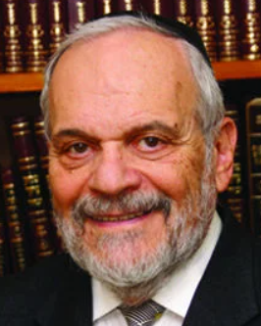

One of the main garments that the High Priest of Israel donned was the jewel-bestudded breastplate – *choshen* - that he wore upon his chest. This breastplate contained twelve precious jewels of different colors and on each of the stones was engraved the name of one of the tribes of Israel.

In addition to these stones there were two large elongated diamond stones that were embedded in the shoulder straps of the apron – *eiphod* – that the High Priest wore. Engraved on those shoulder strap stones were the names of the Patriarchs of Israel and a reference to all of the tribes of Israel. Thus, all of the twenty two letters of the Hebrew alphabet were to be found on these stones in the breastplate and on the shoulder straps.

This allowed these stones and their engraved letters to serve as the *urim* *v’tumim* – the means of prophecy by which important national issues could be decided with Divine help and intervention. Though the letters of the answer shone on the stones, the ability to string the letters together correctly and coherently into the necessary words and message depended upon the prophets of Israel who “read” the *urim* *v’tumim* accurately.

This was symbolic of the symbiotic relationship, so to speak, of G-d and the Jewish people in pursuit of the national and spiritual goals of Israel. Only by this interaction of Heaven and humans could the message of the *urim* *v’tumim* have any constructive meaning. Heaven alone never completely determines our future. We must also work and strive, interpret and analyze, study and act in order to see our future realized successfully.

In the pocket of the *choshen* there was inserted a piece of parchment with the ineffable name of the L-rd written upon it. This was the engine that powered the miracle of the *urim* *v’tumim.*Without its presence the *choshen*was a lifeless collection of jeweled stones. This significance is part of Jewish tradition.

Beauty and expensive value are only relevant when they are somehow inspired and created for a lofty purpose of spirit and service. King Solomon wisely said that “if the L-rd builds not the city then those that have constructed it have toiled in vain.”

In Second Temple times the *choshen* was present on the breast of the High Priest. But the *urim* *v’tumim* was no longer in effective operation. The human element of service and dedication was already lacking. There were no longer prophets present amongst Israel and the *choshen* therefore was merely an ornament, part of the uniform of the High Priest but no longer a G-dly guide to the future and a source of instruction to the people of Israel.

Because of this, the great men and rabbinic leaders of Second Temple times in the Land of Israel recognized early on that this Temple was ultimately doomed to be destroyed. The necessary interplay of Heaven and earth, of G-d and His creatures were no longer present. In such an environment, no matter how beautiful the structure or how handsome the jewels may have been, the whiff of eternity upon which all Jewish life is based was absent. It is our task to somehow restore the very same *urim* *v’tumim* in our personal and national lives.

*Reprinted from this week’s website of rabbiwein.com*

**How Can Judaism Command One to Know G-d Exists?**

**By Rabbi Nechemia Coopersmith**



*Either you believe in G-d, or you don’t. If you do, the commandment is redundant. If you don’t, it’s irrelevant.*

The first of the Big Ten is the commandment to know that G-d exists. But how does this commandment make sense? Either you believe in G-d, or you don’t. If you do, what point is there in being given the commandment – you already believe in G-d. (The Jews who stood at Mount Sinai and received this commandment directly from G-d certainly knew G-d existed – they were speaking to him!)

And for those who don’t believe in G-d, the commandment is irrelevant. There can be no commandment without prior recognition of the Commander. It’s just a line written in an ancient book that has no bearing on my life.

So, for whom is this commandment? It’s either redundant or irrelevant.

To answer this question, we need to first define two important terms: belief (in Hebrew *emuna*) and knowledge (in Hebrew *da’at*).

Bottom of Form

**To Believe and to Know**

Interestingly, *The Way of G-d*, Rabbi Moshe Chaim Luzzato’s classic work on Jewish philosophy, starts: “Every Jew must believe and know that there exists a first Being, without beginning or end…” He uses both verbs – to believe and to know – indicating that they are two distinct entities. How do we define these terms and why does belief come before knowledge?

Here are two possible approaches.

**First Belief, Then Knowledge**

When I first came to Aish in Jerusalem a lifetime ago, I wasn’t observant. I was learning and about Judaism and exploring the various arguments given for G-d’s existence and the claim that G-d gave the Torah to the Jewish people at Mount Sinai. I didn’t want to make any changes in my lifestyle due to social pressure or for the emotional payoff of the experience. I was trying to be objective and make rational decisions.

At what point can I no longer ignore the Torah commandments just because I don’t feel like observing them?

After learning at Aish for a few months, Shabbat began to post a challenge for me. I needed to decide when I had to actually start observing Shabbat. At what point can I no longer ignore the Torah commandments just because I don’t feel like observing them? How much evidence do I need to have that all this Jewish stuff may in fact be true?

**When it Becomes Irrational to Ignore the Evidence**

When making strictly rational decisions (which I realize is not often the case), when the scales tip in one way while weighing up the evidence, it’s more sensible to go where the evidence lies – even if the scales tip only at the 51% mark. At that point, I have barely enough compelling evidence to believe that this is true. Do I *know* it? Certainly not. I was unsure and had plenty of questions and doubts. But at some point it became irrational to ignore the evidence. I was on the hook. I entered the initial realm of *belief* based on a preponderance of evidence.

Once I believed in G-d, the commandment to *know* that G-d exists kicks in. I recognized that there’s a good chance He exists and gave the Torah. The Torah is telling me: don’t stop there. You have plenty of questions and doubts. Work on getting to the realm of knowledge by addressing your fundamental questions, and amass more compelling evidence that will propel you higher up the ladder of certainty, moving from the realm of belief to knowledge.

The first commandment is the demand to get clarity and discover the truth. Move from belief to knowledge.

According to this explanation, the commandment to know G-d exists is directed to one who has a tenuous belief in G-d based on a certain amount of evidence. The commandment is directing him to build a strong, rational foundation for his convictions. He shouldn’t run away from his questions nor simply assume G-d exists. The first commandment, the bedrock of Torah, is the demand to get clarity and discover the truth. Move from belief to knowledge.

Biblical Knowledge

The second explanation is based on a different definition of belief and knowledge. In the Torah, the Hebrew term for knowledge, *da’at*, is used to connote sexual intimacy. “Now the man knew his wife, Eve, and she conceived and bore Cain” ([Genesis, 4:1](https://www.sefaria.org/Genesis.4.1?lang=he-en&utm_source=aish.com&utm_medium=sefaria_linker)). This is “knowing” in the biblical sense, carnal knowledge.

The deepest form of knowledge doesn’t reside only in the head; it needs to penetrate the heart.

**What it Means to Truly Know Something**

Why should the word “to know” also mean intimacy? The connection reveals what it means to truly knowing something. The deepest form of knowledge doesn’t reside only in the head; it needs to penetrate the heart. Full knowledge is integrated wisdom; it’s being intimate with what you know.

To illustrate, imagine a smoker who visits a cancer ward. He already knows intellectually that smoking is dangerous and causes cancer. Hard to ignore those big black and white words emblazoned on the package: SMOKING KILLS. Yet something shifts, at least for a few moments, upon leaving the cancer ward where saw upfront the stark, horrific reality of dying from lung cancer. It will take at least five minutes before he lights up.

Intellectually, nothing changed. The smoker already had the facts about the dangers of smoking. But seeing the reality firsthand enables his intellectual understanding to penetrate his heart. That makes it real. Now he really knows that smoking kills.

**We Do it Every Day**

The commandment to know G-d exists is the directive to integrate your belief, your intellectual understanding, and make it part of the very fiber of your being. Assimilate it, live with it. It’s very easy to ignore G-d if one only has an intellectual belief that He exists. We do it every day. The first commandment is giving us the enormous challenge to *live* with what you know to be true, to feel that G-d is an active, dynamic part of your life, right here with you. Without the emotional component, G-d is just an abstract, sterile concept that could have no impact on your life.

The distance between the mind and the heart is greater than the distance between the earth and the moon.

Rabbi Eliyahu Dessler, a leading Jewish philosopher of the 20th century, said that the distance between the mind and the heart is greater than the distance between the earth and the moon. Coming to the conclusion that G-d exists is the easy part. Integrating that belief is the far greater challenge.

According to this explanation, belief is the intellectual realm. The mind comes first; it’s what tells us what is true. Then comes knowledge, *da’at*, bridging the gap between the mind and heart. Living with the reality of G-d’s existence and building a passionate relationship with Him is a constant challenge for every person who believes in G-d.

So, the first commandment applies to every Jew throughout the generations.

*Reprinted from the January 19, 2023 website of aish.com*

**A Not-So-Simple**

**Cup of Coffee**

**By Rabbi Mechel Handler**

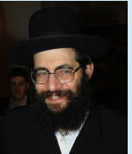

**Rav Tzvi Meir Zilberberg**

Using an example from everyday life, Rav Tzvi Meir Zilberberg describes how we can awaken in ourselves the proper thoughts and feelings by instilling proper kavanah into the berachos we recite. Many of us start the day with a cup of coffee. When you take that cup of coffee in your hand, think for a moment and say to yourself, “Hashem put thousands of people to work on my behalf, so that I should be able to drink this cup of coffee. [See Berachos 58a, which describes how Adam had to work for his bread — while for us, the table is all set.]

Hashem arranged for people to plant and grow coffee beans, grind them into coffee, produce sugar, process milk, manufacture the coffee mug, pay for the rabbinic supervision, transport the coffee, market it, advertise it, distribute it, and so on — not to mention the people who built the house where I’m sitting and drinking my coffee.

All this came to my doorstep from the four corners of the earth, and Hashem brought about all these components, and all this activity, just for me, so that I can enjoy this cup of coffee right now.

And what a chessed it is that He gave me a healthy body and mouth with which to enjoy it, and not a feeding tube or IV drip, lo aleinu!” By engaging your mind and heart in this type of contemplation, you will acquire a totally new outlook on life, and your berachos will be transformed into something much more meaningful.

Now, when you hold the cup of coffee and say the word “baruch,” you will be declaring that this cup of coffee comes from Hashem, the Source of all blessings. It is a gift from Hakadosh Baruch Hu that demonstrates His deep love for you.

*Reprinted from the Parshas Tetzaveh 5782 edition of At the ArtScroll Shabbos Table. Excerpted from the ArtScroll book – “Make Your Berachos More Meaningful.”*

**Learning from Aaron**

And you bring close, to yourself, Aaron your brother (28:1) Moshe and Aaron were of entirely different natures. Moshe was given to seclusion and contemplation, as it states, "And Moshe took his tent and went outside the camp," whereas Aaron was a social being, involved with his fellow man and pursuing peace.

G-d's directive to Moshe implied that he should emulate his brother's ways, for a true Jewish leader cannot remain apart from his people. (Rabbi Meir of Premishlan)

*Reprinted from the Parshat Tetzveh 5783 email of R’ Yedidye Hirtenfeld’s whY I Matter parsha sheet for the Young Israel of Midwood in Brooklyn. May Hashem comfort Yedidye and his family on the petirah this past Shabbos of his daughter Alte Hirtenfeld*